**Git Punishment (21st Oct 2024)**

**Sahil Shah**

**150096724032**

**Steps:**

1. Start terminal
2. 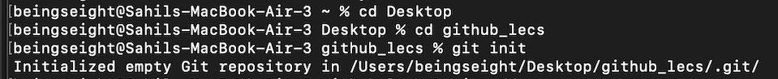

(to initialize, the path and later a repository is initialized)

Git init initializes a new repository

After that there is blank so it initializes empty repository instead by mentioning a directory we can initialize in specific directory

Adding a -bare will create a bare repository

1. 

(git adds all the changes with git add .) command,

And a commit is committed whereas “FirstCommit” in which the “” in between is the message to describe change of the commit

1. 

Connects the local repository to a remote repository

1. 

Push the changes to remote repository

1. 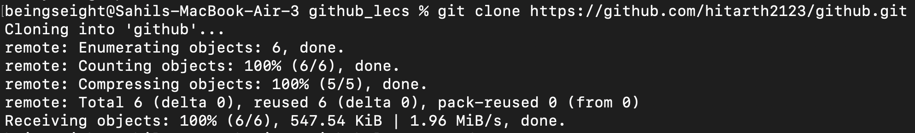

Clones a repository of someone else

Here it cloned a repository of my friend

1. 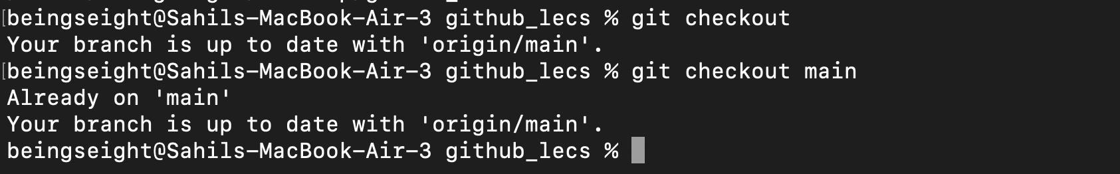

Checkouts the origin

Specifying main means checkouts the exact branch